Online Gym Management System Application Documentation

# Project Information

Project Name: Gym Management System Application

Project Description: A web-based application designed to manage various gym operations such as member registration, fee management, and scheduling.

Version: 1.0

Developer: Adish Jain

Date: June 2024

# Table of Contents

1.Introduction  
2. Features and Functionalities  
3. Technologies Used  
4. System Requirements For Development  
5. Installation and Setup  
6. User Guide  
7. Developer Guide

8.Project Structure

9. Understanding of Databases  
10. Troubleshooting  
11. Conclusion

# Introduction

**Project overview:** This project is a comprehensive system to streamline gym management, allowing for effective member and schedule management.

**Goals and objectives**: To provide a digital solution for gym operations, improving efficiency and user experience.

**Target audience**: Gym owners, managers, and staff.

# Features and Functionalities

**User Authentication and Registration**: Allows users to register and authenticate securely.

**Gym Slot Scheduling Interface**: Provides an interface for scheduling gym slots or classes.

**Slot Availability Management**: Manages and displays available gym slots for booking.

**Slot Booking Information Management**: Handles booking information and reservations for gym slots.

**Feedback Management**: Manages feedback from gym members.

**User Management:** Manage gym user

**Admin Dashboard**: Provides administrators with a dashboard to manage users, slots, items, and system settings

# Technologies Used

**Programming languages**: Java & JavaScript

**Frameworks and libraries**: Spring Boot

**Databases**: MySQL 8

**Other tools and technologies**: Maven for project management, Apache Tomcat 9.x, CSS,JSP and Servlet

# System Requirements For Development

**Hardware requirements:**

Standard server or local machine with sufficient RAM and storage

**Software requirements:**

JDK 17 or higher

Apache Tomcat 9.x

MySQL 8

Maven

IDE (e.g., IntelliJ IDEA or Eclipse)

Network requirements: Basic internet connectivity for accessing the application

# Installation and Setup

**1. Clone the repository:**  
 git clone https://github.com/AdityaBondre/GymManagementSystemApplication.git  
  
**2. Navigate to the project directory:**  
 cd GymManagementSystemApplication  
  
**3. Build the project using Maven:**  
 mvn clean install  
  
**4. Run the application:**  
 mvn spring-boot:run  
  
**5. Deploy on Apache Tomcat:**

Configure Tomcat to deploy the application.

# User Guide

**How to use the system**:

Log in with your credentials to access various modules like member management, fee tracking, and scheduling.

**User interface overview**:

A dashboard with navigation options for different modules.

# Developer Guide

Code structure and organization:

src/main/java: Contains all Java source files

src/main/resources: Configuration files and templates

APIs and interfaces: RESTful APIs for managing different resources.

Development environment setup:

Install JDK, MySQL, and Maven

Import the project into an IDE

Configure database settings in application. Properties

# Project Structure

* **Bean file**
* Feedback.java
* GymBook.java
* GymItem.java
* GymUser.java
* Slot.java
* SlotItem.java
* SlotItemEmbed.java
* **Config file**
* EncoderConfig.java
* SecurityConfig.java
* **Controller file**
* GymController.java
* LoginController.java
* **Dao file**
* FeedbackRepository.java
* GymBookDao.java
* GymBookDaolmpl.java
* GymBookRepository.java
* GymltemDao.java
* GymltemDaolmpl.java
* GymltemRepository.java
* GymUserRepository.java
* SlotDao.java
* SlotDaolmpl.java
* SlotItemDao.java
* SlotItemDaolmpl.java
* SlotItemRepository.java
* SlotRepository.java
* **Exception file**
* DuplicateBookingException.java
* FeedbackException.java
* UserDeletionException.java
* SeatNotAvailableException.java
* **Service file**
* GymUserService.java
* FeedbackService.java
* GymItemService.java
* **Resource file**
* **Static**
* **Images**
* **Templaets**
* **application.properties**
* **Jsp pages**
* bookingCardPage.jsp
* error.jsp
* feedbackListPage.jsp
* feedbackPage.jsp
* feedback-success.jsp
* gymBookCancelPage.jsp
* gymBookReportPage.jsp
* gymltemEditPage.jsp
* gymltemEntryPage.jsp
* gymltemReportPage.jsp
* index1.jsp
* index2.jsp
* loginErrorPage.jsp loginPage.jsp
* newUserRegistration.jsp
* slotBookPage1.jsp slotBookPage2.jsp
* slotEditPage.jsp slotEntryPage.jsp
* slotReportPage1.jsp
* slotReportPage2.jsp
* userListPage.jsp

# Understanding of Databases

**Key Tables and Their Descriptions:**

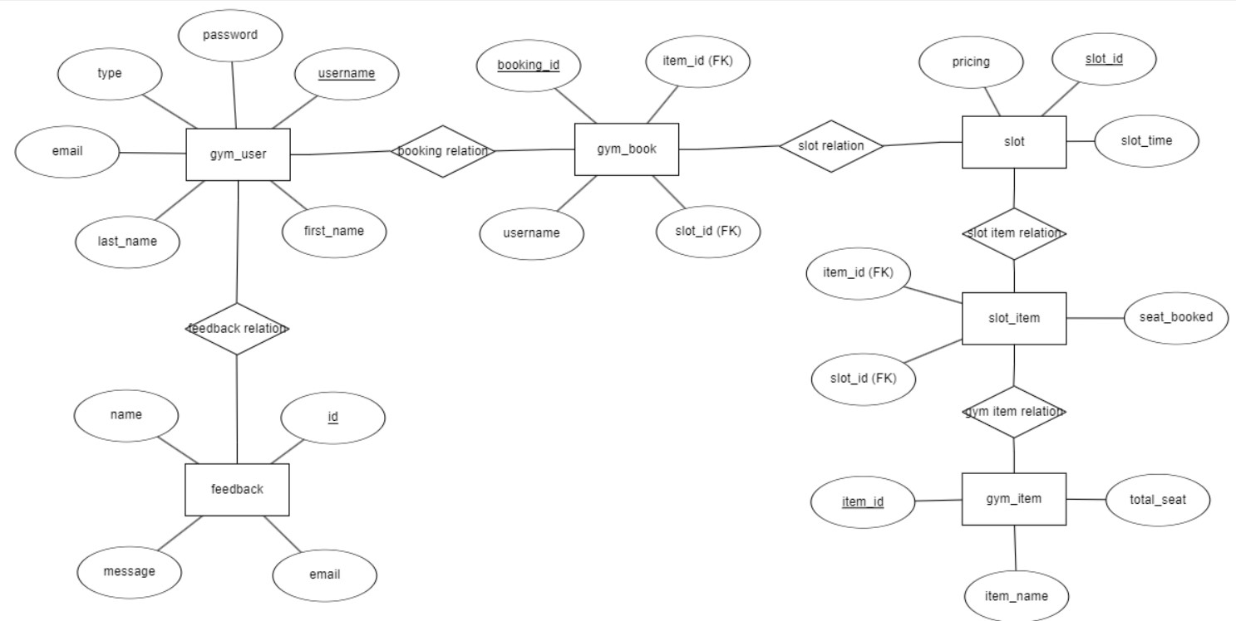

**Database Access:**

* The application uses Java Database Connectivity (JDBC) to interact with the MySQL database. Spring Boot's Data JPA is leveraged to simplify data access and manipulation through repositories and entities.

# Troubleshooting

Common errors and solutions:

**Application not starting**: Check the logs for errors related to missing dependencies or configuration issues.

**Database connection issues:** Ensure the database is running and the connection settings are correct.

**Debugging techniques:** Use the IDE's debugging tools to set breakpoints and inspect variables.

# Conclusion

Summary of the project: The Gym Management System Application aims to digitize gym operations, making management more efficient and user-friendly.

Lessons learned: The importance of modular design and clear documentation.

Final thoughts: Further improvements will continue to enhance the system’s usability and functionality.